|  |  |
| --- | --- |
| U.S. Radiocommunications Sector  Fact Sheet | |
| **Working Party:** ITU-R WP 7B | **Document No:** US7B_27_009_ R04 |
| **Ref:** Annex 8 to the WP7B Chairman’s Report,  Resolution **680 (WRC-23),**  WRC-27 Agenda Item **1.15** | **Date:** 2 February 2024\ |
| **Document Title:** WORKING DOCUMENT TOWARDS A PRELIMINARY DRAFT NEW REPORT ITU-R SA.[LUNAR.SRS STATIONS CHAR] | |
| **Author(s)/Contributors(s):**  Name: Scott Kotler  Org: Lockheed Martin Corporation  Name: Steve Baruch  Org: NWSP for Lockheed Martin Corporation  Name: Catherine Sham  Org: NASA  Name: Dennis Lee  Org: NASA (JPL)  Name: Dave Franc  Org: NASA | Phone: (703) 789-3923  Email: scott.kotler@LMCO.com  Phone: (240) 476-2600  Email: sbaruch@newwavespectrum.com  Phone: (281) 483-0124  Email: catherine.c.sham@nasa.gov  Phone: (818) 205-7623  Email: dennis.k.lee@jpl.nasa.gov  Phone: (216) 327-5459  Email: david.n.franc@nasa.gov |
| **Purpose/Objective:** The purpose of this contribution is to further progress the working document in WP7B with operational and technical characteristics of SRS stations on the lunar surface, and SRS systems in lunar orbit communicating with systems on the lunar surface consistent with *Resolves to Invite the ITU-R* 1 and 2 of Resolution **680 (WRC-23),** and to make other modifications to align the working document with WRC-27 agenda item **1.15** and Resolution **680 (WRC-23)**. | |
| **Abstract:** WRC-23 adopted Resolution **680** and WRC-27 Agenda Item **1.15** that includes studies related to SRS systems which may operate on the lunar surface, or in lunar orbit communicating with SRS systems on the lunar surface, in the following frequency ranges or portions thereof.   * 390-406.1 MHz, 420-430 MHz and 440-450 MHz, limited to outside the SZM * 2 400-2 690 MHz, 3 500-3 800 MHz, 5 150-5 570 MHz, 5 570-5 725 MHz, 5 775-5 925 MHz, 7 190-7 235 MHz, 8 450-8 500 MHz and 25.25-28.35 GHz | |

|  |  |
| --- | --- |
| **Radiocommunication Study Groups** |  |
|  |  |
|  |  |
| Received:  Reference: Resolution **680 (WRC-23)** | **Document 7B/ABC-E** |
| **XX March 2024** |
| **English only** |
| United States of America | |
|  | |
| update to WORKING DOCUMENT TOWARDS A PRELIMINARY DRAFT NEW REPORT ITU-R SA.[LUNAR.SRS Stations CHAR] | |

Based on the results of CPM27-1, Working Party 7B is responsible for conducting studies and preparation of draft CPM text under WRC-27 agenda item 1.15 on lunar communications related to systems in the Space Research Service which may operate on the lunar surface, or systems in lunar orbit communicating with systems on the lunar surface in specific frequency ranges called out in Resolution **680 (WRC-23)**.

WP 7B initiated a working document to capture concept of operations and technical characteristics of systems for Lunar operation during the 2019-2023 study cycle. This input contribution seeks to progress the working document in WP7B by providing operational and technical characteristics of SRS stations on the lunar surface, and SRS systems in lunar orbit communicating with systems on the lunar surface consistent with *Resolves to Invite the ITU-R* 1 and 2 of Resolution **680 (WRC-23)**.

Attachment.

|  |  |
| --- | --- |
| **Radiocommunication Study Groups** |  |
|  |  |
|  |  |
| Source: Document Annex 8 to Document 7B/277 (Study Period 2019-2023) | Document 7B/ABC-E |
| XX March 2024 |
| English only |
| WORKING DOCUMENT TOWARDS A PRELIMINARY DRAFT NEW  REPORT ITU-R SA.[LUNAR.SRS STATIONS CHAR] | |
| Concept of operations for, and technical and operational characteristics of, space researchsystems for Lunar operations | |

(202X)

Scope

Direct communications between landers, rovers, extravehicular activity (EVA) astronauts conducting sortie missions and experiments is crucial to enable effective scientific activities and consideration of the health of the crew in the lunar environment. Considering the unique topology of the Moon’s surface, shielded zone of the Moon (SZM) considerations, unique science opportunities in radio astronomy, and remote sensing in the lunar region/surface, technical and operational characteristics are required to determine the feasibility of frequency bands to support any envisioned lunar surface network using standards-based technologies. This report describes the concept of operations for communications in the vicinity of the Moon, including on its surface and with lunar orbiting satellites, and identifies as examples certain technical and operational characteristics for the different use cases on the Moon’s surface and by lunar-orbiting systems communicating with systems on the Moon’s surface.

Keywords

EVA, landers, rovers, Moon, surface, shielded zone of the MoonGlossary / Abbreviations

EVA Extravehicular Activity

LCT Lunar Communications Terminal

LTV Lunar Terrain Vehicle

RF Radio Frequency

SZM Shielded Zone of the Moon

PNT Positioning, Navigation, and Timing

Related ITU Recommendations and Reports

TBD

# 1 Introduction

The need exists to support the most efficient and effective use of spectrum resources on the surface of the moon and in the lunar orbit for short-term and long-term communications and continuous commercial and scientific operations on and around the Moon. Operations in the lunar space include communications in the vicinity of the Moon, including its surface and in the lunar orbit.

# 2 General overview

Administrations in all three ITU Regions have announced and are pursuing lunar missions, with remote unmanned exploration already underway, and with human visits to the Moon set to occur as early as 2026. Technological and business model development is underway, and much of this development will transcend the scientific arena and include commercial activity.

It is of utmost importance to the successful exploration and conduct of continuous operations on the Moon for there to be a reliable, understandable, usable, and flexible communications architecture in place to handle operational scenarios for a few users or multiple groups of users. The timely and effective development of this architecture is essential, at a minimum, to the advancement of lunar exploration, scientific research, and other activities.

The framework for how the substantial communications requirements for operations in lunar/cislunar space (i.e., cislunar communications relay and data services for missions on the lunar surface and in lunar orbit) and beyond will be structured is rapidly taking shape. Systems have been and are being designed to create an internet-like architecture to support lunar missions. One of these systems, the LunaNet architecture,[1] is designed to promote maximum interoperability and to enable use by a broad range of lunar region missions and has been adopted by the Interagency Operations Advisory Group (IOAG).[2] LunaNet will include networking services capable of communication between nodes; positioning, navigation, and timing (PNT) services for orientation and velocity determination; time synchronization and dissemination; and science services providing situational alerts and scientific measurements. Space agencies around the world are developing similar initiatives including jointly developing network architectures to lay the groundwork, through governmental investments and pathfinding missions, for maximum interoperability and to facilitate space commerce development in the years to come. Presently commercial development of lunar surface and lunar orbit communications systems in the form of public/private partnerships characterize significant aspects of space activities – from launch services to space transportation and more.

Envisioned systems are being designed to enable communications to and from Earth (Earth station) for lunar assets (service users in lunar orbit and on the lunar surface) through lunar orbiting relay satellites (space stations). Communications links, coupled with radiometric navigation techniques to provide location, velocity, and time information to assets on the lunar surface and in lunar orbit, will also be used. The planned systems will provide real-time relay capabilities when both ends of the link (Moon and Earth) are visible.

Some core elements likely to be included in all systems would include:

– Lunar surface communications (notional concept of operation in Figure 1)

• Functionally similar to terrestrial mobile services topology and standards-based wireless communication topologies.

• These links also include stations near the lunar surface.

• These links are used for direct local area communications between spacesuits, experiments, habitation, other lunar assets and communication stations, landers, rovers, and extravehicular activity (EVA) supporting sortie missions and experiments. These links are crucial to enable effective scientific activities and health monitoring of the crew and equipment in the lunar environment.

• All lunar surface communications will use space-hardened equipment in closed systems, within a service radius and have no direct communication with Earth-centric systems.

• In some cases, existing spectrum allocations in the Space Research Service or Inter-Satellite Service are used to provide direct communication with Earth and intra-lunar relay communication capabilities. Spectrum needs will determine if these existing allocations could enable implementation of needed local area point-to-multipoint network capabilities that leverage advanced wireless technologies for envisioned applications.

– Lunar surface to/from lunar-orbiting satellites

• The reference mission concepts involve scenarios where multiple exploration EVA teams are tens of kilometers from the lander/habitats and each other, resulting in the need for support from lunar-orbiting satellites to accomplish mission objectives.

• These links are similar to Earth-to-space/space-to-Earth links but use the Moon in place of the Earth.

• All operations will occur on lunar surface and in lunar orbit, with no direct interaction with Earth-centric systems.

• In some cases, existing spectrum allocations in the Space Research Service (space-to-space) or Inter-Satellite Service could be used to support these links; in other cases, additional frequency bands would help to leverage existing commercial standards and equipment.

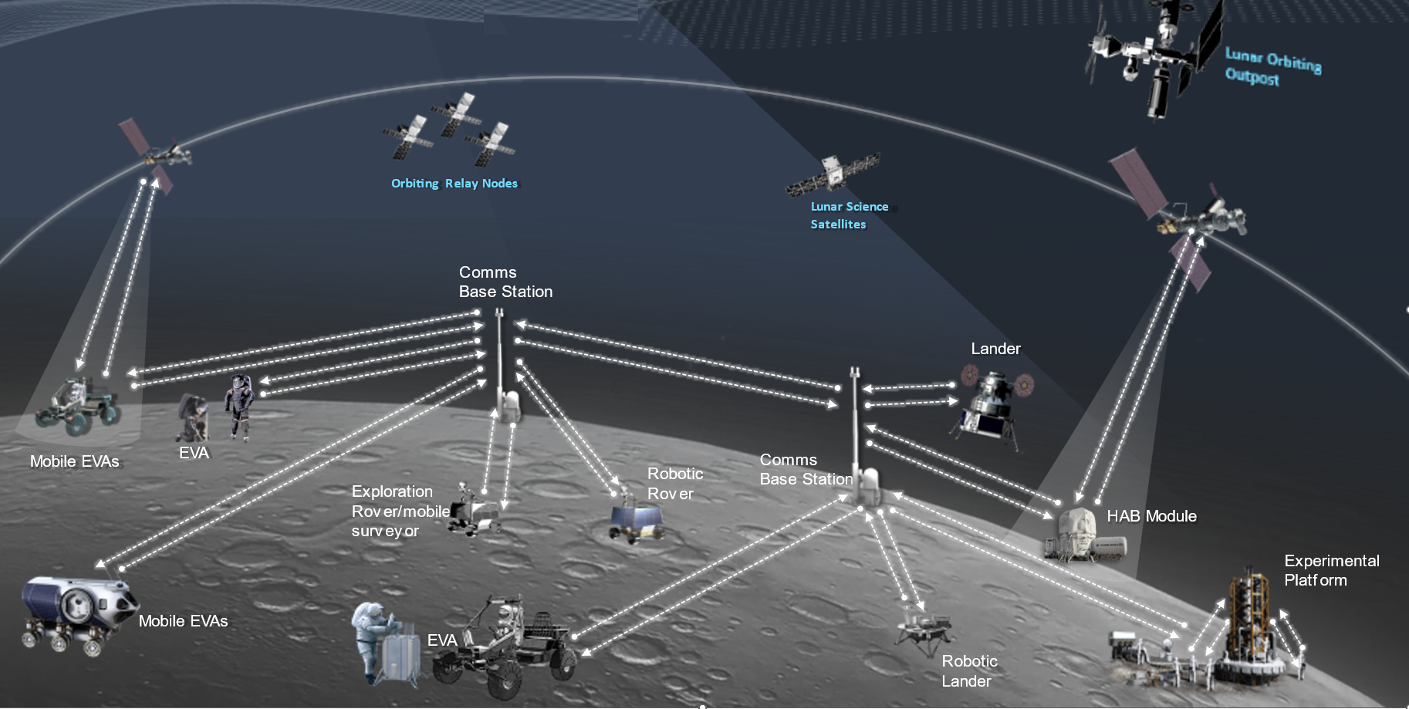

Figure 1. Notional Lunar Surface Scenario

# 3 Concept of operations for communications in the vicinity of the Moon, including its surface and with lunar orbiting satellites

## 3.1 Use cases

– For scientific lunar robotic and human surface missions, there are 3 categories of elements involved in the radio frequency architecture: surface elements, in-space elements and Earth-based elements. The radio links between the in-space elements and the Earth-based elements are planned to utilize spectrum that is currently allocated to space research service (space-to-Earth) (Earth-to-space) and supported by multiple networks of ground stations. In-space elements include transportation spacecraft, space platforms and relay satellites. These in-space elements around the Moon’s orbits may possess capabilities to communicate with the Earth, with another spacecraft/platform/satellite in the Moon’s orbit, and surface elements, depending on their individual mission objectives and whether humans are onboard. For surface elements, there are stationary and non-stationary elements with or without direct links to the Earth or an in-space element but always maintain communication with another surface element. The ubiquitous connectivity between surface elements is the means to maximize scientific return and to serve as the safety net to maintain visibility to the instrumentation and astronauts working/traveling on the Moon. Spaceflight lessons-learned confirmed a RF architecture with a minimum number of single point failures and redundancy to enable link connectivity to and between in-space and surface elements is essential, especially in the initial scientific mission roadmap for future missions. Additionally, regulatory certainty and protection are fundamental in spaceflight missions.

* In-space and surface elements described above and in this Report are space stations in the Moon’s orbits or on the Moon’s surface, as confirmed by the outcome of the BR’s examination of the Radio Regulations and contained in the Director’s Report to the WRC-23.
* The spectrum needs analysis for each category of elements called out above are included below.
* Various frequency ranges (low band, high band) are needed to address varying data rate requirements and distances from the base camp for different expedition crews. Reliable communications including high-definition video, clear audio, high speed bi-directional data transfer between the base camp and each element in a point-to-multipoint network topology that leverages existing commercial technologies would reduce development cycles and non-recurring costs. Additionally, higher frequency bands can support wider bandwidths for increased data throughput, local network capability for high activity areas, and point-to-point links for throughput and/or greater distances. Selecting potential frequency bands that have commonality with earth-based services leads to efficiencies in hardware and testing.

– A number of user scenarios are planned for compatible local communications, for example between a surface vehicle and an orbiter, between surface vehicles, and between orbiters. Sufficient frequency separation is also required to enable compatible and simultaneous communications in the lunar space. As such, a variety of frequencies may be needed to address this type of operation.

– Additional use cases requiring radio communications include space suits, handhelds, robotic landers and payloads, lunar vehicles, extravehicular activity (EVA), robotic rovers, habitation system support, manufacturing assets, and human landing systems. Such systems require spectrum access on both Lunar Surface and with Lunar Orbiting Satellites.

Table 1. Lunar Surface Use Cases and Data Rates

|  |  |  |  |
| --- | --- | --- | --- |
| **Users** | **Service Type** | **Typical Data Rate per User** | **Max Data Rate per User** |
| EVAs | Voice/data (comm & PNT)/ video | 3 - 12 Mbps | 100 Mbps |
| Stationary Comm Terminal | Voice/data (comm & PNT)/video | 30 Mbps | 100 Mbps |
| Non-Stationary Terminals (Landers, Rover) | Voice/data (comm & PNT)/video | 3 - 16 Mbps | 100 Mbps |
| In-Space and Surface Elements | PNT | 500 bps | TBD |
| Rover - LCT | Voice/data (comm & PNT)/ video | 3 Mbps | TBD |
| EVAs – Landers, Rover | Voice/data (comm & PNT)/video | 3 Mbps – 30 Mbps | 100 Mbps |
| Surface Elements Network | Voice/data (comm & PNT)/video | TBD | 100 Mbps |
| Surface Backhaul | Voice/data (comm & PNT)/video | 9.5 Mbps | 1 Gbps |

## 3.2 Lunar surface communications

These communication links include both those on the lunar surface as well as those near the lunar surface. The links can be limited to a range up to 50 km to enhance technical compatibility and frequency re-use.

– Communication technology is well-developed and widely deployed on the Earth using industry standards that could be applied to lunar communications.

### 3.2.1 EVA Communications - Operational and technical capabilities

The EVA suit provides voice/data/video service for astronauts performing activities on the lunar surface outside of the habitation module or lunar vehicle. The EVA concept of operations involves different scenarios, including short range direct links between astronauts and longer range line-of-sight links between the astronaut and a lunar communications terminal on a lander or lunar terrain vehicle (LTV). The astronaut may also command a rover for remote exploration of the lunar surface during the EVA.

The EVA communications system is designed to provide astronauts with full audio/video capabilities at walking distances up to 2 km from the lander/LTV, with data rates up to 12 Mbps for high definition video. For contingency walk-back scenarios where the astronaut must walk back to the lander or habitation module, the EVA link is required to support telemetry data and voice up to 10 km. Due to propagation loss at higher frequencies which impacts the coverage area, critical EVA communications are best suited for frequencies below 6 GHz.

Figure 2. Example of EVA Suit

Table 2. Typical Technical Characteristics of Lunar Surface EVA Communications

|  |  |  |  |  |  |  |  |
| --- | --- | --- | --- | --- | --- | --- | --- |
| EVA Links | Data Rate per User | Number of Links per User | Total Data Rate | Max Distance | Antenna Height (AGL) | Peak Antenna Gain | Frequency Band(s) |
| EVA Suit-to-Suit Comms | 100 kbps  (voice and data) | Up to 4 | 400 kbps | 200 m | 1.5 - 2 meters | 3 dBi | TBD |
| EVA  (to lander/ LTV) | 64 kbps (voice)  34 kbps (data)  3 – 12 Mbps (video) | 1 | 12.1 Mbps | 2 km | 1.5 - 2 meters | 3 dBi | TBD |
| EVA  (to rover) | 100 kbps  (commands) | 1 | 100 kbps | 2 km | 1.5 - 2 meters | 3 dBi | TBD |
| EVA Contingency (Walk-back) | 98 kbps (required; voice and data only)  Up to 3.1 Mbps (voice, data, and limited video depending on range and link availability) | 1 | 3.1 Mbps | 10 km | 1.5 - 2 meters | 3 dBi | TBD |

### 3.2.2 Lunar Communications Terminals on Stationary Platforms - Operational and technical capabilities

The habitation module and lunar lander are examples of stationary platforms on the lunar surface that may host a lunar communications terminal. The lunar lander is considered a stationary platform because it does not move after landing on the lunar surface, even though it moves during the ascent and descent phases. Under the envisioned con-ops, the lander will provide EVA communications to the crew members after landing including voice, data, and video. The lander may also transmit to a lunar terrain vehicle, primary for commanding. The LCT on the lander may also be used to command pressurized rovers used for remote surface exploration.

Table 2 shows some typical characteristics for LCTs on a stationary platform, using the lander as an example.

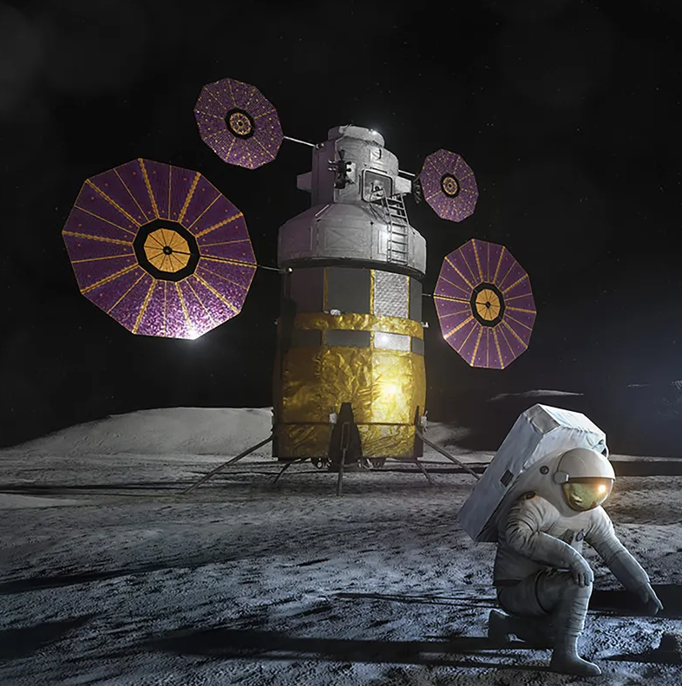

Figure 3. Pictorial Example of a Lunar Lander (stationary LCT)

Table 2. Typical Technical Characteristics of Stationary LCTs

|  |  |  |  |  |  |  |
| --- | --- | --- | --- | --- | --- | --- |
| LCT on Stationary Platform | Data Rate per link | Number of Links | Total Data Rate | Max Distance | Antenna Height (AGL) | Frequency Band(s) |
| Lander  (to EVA) | 64 kbps (voice)  3 Mbps (video) | 4 | 12.3 Mbps | 10 km | 16 - 30 meters | TBD |
| Lander  (to LTV) | 100 kbps  (commands) | 1 | 100 kbps | 10 km | 16 - 30 meters | TBD |
| Lander  (to Pressurized Rover) | 20 kbps (commands) | 1 | 20 kbps | 20 km | 16 - 30 meters | TBD |

### 3.2.3 Lunar Communications Terminals on Non-Stationary Platforms - Operational and technical capabilities

Examples of non-stationary platforms deployed on the lunar surface include the lunar terrain vehicle (LTV) and robotic rovers. The LTV (shown in Figure 3) provides transport for the crew members, while the robotic rovers carry instrument payloads for lunar exploration and scientific discovery.

Both the LTV and rovers will host lunar communication terminals. Under the envisioned con-ops, the LTV is assumed to support up to 2 crew members with full voice, data, and video capability. In addition, the LTV will host 2 high definition cameras and various scientific payloads. To support these functions, the LTV communications terminal is required to accommodate at least 16 Mbps data rate. Depending on the mission scenario, the LTV communicate with fixed surface assets (such as a lander or habitat module), EVA suits, and/or with other non-stationary platforms such as rovers. The LTV may also serve as a portable relay point between two lunar surface elements.

The rover is assumed to host a camera as well as various scientific instruments. The rover communications terminal will transmit video and data, and receive commands for remote operations. Similar to the LTV, the rover may communicate with fixed/stationary surface assets, EVA suits, and/or other non-stationary platforms.



Figure 4. Pictorial Example of Lunar Terrain Vehicle (non-stationary LCT)

Table 3. Typical Technical Characteristics of Non-Stationary LCTs

|  |  |  |  |  |  |  |  |
| --- | --- | --- | --- | --- | --- | --- | --- |
| LCT on Non-Stationary Platform | Data Rate per link | Number of Links | Total Data Rate | Max Distance | Antenna Height (AGL) | Peak Antenna Gain | Frequency Band(s) |
| LTV  (to EVA suit) | 3 – 12 Mbps (voice, data, and video) | 2 | 6-24 Mbps | 2 km | 3 meters | 3 dBi | TBD |
| LTV  (to rover) | 100 kbps  (commands) | 2 | 200 kbps | 2 km | 3 meters | 3 dBi | TBD |
| LTV  (to stationary platform) | 16 - 100 Mbps  (voice, data, and video) | 1 | 16 - 100 Mbps | 10 km | 3 meters | 3 dBi | TBD |
| Rover  (to EVA suit) | 3 Mbps  (video and data) | 1 | 3 Mbps | 2 km | 1 meter | 3 dBi | TBD |
| Rover  (to LTV) | 3 Mbps  (video and data) | 2 | 6 Mbps | 2 km | 1 meter | 3 dBi | TBD |
| Rover  (to stationary platform) | 3 Mbps  (video and data) | 2 | 6 Mbps | 10 km | 1 meter | 3 dBi | TBD |

### 3.2.4 Operational and technical capabilities for Lunar PNT Data Messaging

The lunar PNT system will transmit navigation messages which are meant to provide users with the data needed to compute the position and time solutions, to aid various receiver tasks, and improve positioning accuracy. The message data rate is low, typically around 500 bps.

### 3.2.5 Operational and technical capabilities for Lunar Surface Backhaul

The lunar surface backhaul is envisioned as point-to-point surface wireless links connecting various cell sites on the Moon to the core network. These may range in data rate from 9.6 Mbps up to 1 Gbps depending on the network traffic demands.

### 3.2.6 Assessment of potential additional frequency ranges for lunar surface networks

– 390-406.1 MHz, 420-430 MHz and 440-450 MHz, limited to outside the SZM

– 2 400‑2 690 MHz, 3 500-3 800 MHz, 5 150-5 570 MHz, 5 570-5 725 MHz, 5 775-5 925 MHz, 7 190-7 235 MHz, 8 450-8 500, and 25.25-28.35 GHz.

### 3.2.7 Propagation considerations (Note: liaison activity with ITU-R SG3 is needed to verify propagation assumptions below)

#### 3.2.8.1 Free Space Path Loss (FSPL) considerations

– FSPL from the Lunar Surface to the Earth’s surface for frequencies above 390 MHz is greater than 195 dB.

– FSPL from Lunar Surface to satellite receivers on the GSO in the frequency range above 25 GHz is greater than 230 dB.

#### 3.2.9.2 Lunar terrain

TBD

## 3.3 Lunar surface to/from lunar-orbiting satellites

### 3.3.1 Operational and technical capabilities

– Where EVA teams are tens of kilometers from the lander/habitats and each other, reliance exclusively on lunar-surface point-to-multipoint networks will not be sufficient, resulting in the need for support from lunar-orbiting satellites to accomplish mission objectives.

– Lunar surface to/from lunar-orbiting satellite links support lunar relay services including low and high-rate mission data, ranging and timing operations, and extend communications to beyond the approximate 50 km range

### 3.3.2 Assessment of potential additional frequency ranges for lunar surface-to/from lunar-orbiting satellite operations

– 390-406.1 MHz, 420-430 MHz and 440-450 MHz, limited to outside the SZM

– 2 400‑2 690 MHz, 3 500-3 800 MHz, 5 150-5 570 MHz, 5 570-5 725 MHz, 5 775-5 925 MHz, 7 190-7 235 MHz, 8 450-8 500 MHz, and 25.25-28.35 GHz.

### 3.3.3 Technical characteristics

### *TBD*3.3.4 Propagation considerations (Note: liaison activity with ITU-R SG 3 is needed to verify propagation assumptions below)

#### 3.3.4.1 Free Space Path Loss (FSPL) considerations

– FSPL from the Lunar Surface to the Earth’s surface for frequencies above 390 MHz is greater than 195 dB.

– FSPL from Lunar Orbit to satellite receivers on the GSO in the frequency range above 25 GHz is greater than 230.4 dB.

#### 3.3.4.2 Lunar terrain

There are multiple application types to be operated within these frequency bands:

### (1) Robotic landers and payloads (Stationary)

(2) Rovers (Non-stationary)

(3) Human landing systems (Stationary)

(4) Spacesuits (Non-stationary)

(5) Handheld terminals (Stationary and Non-Stationary)

(6) Habitation Systems (Stationary)

(7) Power Support (Stationary)

(8) Resource Assets (Stationary and Non-Stationary)

The transmit and receiver parameters are listed in the following tables.

Table 4 Lunar Surface Receiver Characteristics:

|  |  |  |  |
| --- | --- | --- | --- |
| Band (MHz) | 390 - 405 | 440 - 450 | 2483.5-2500 |
| Beam Type | Fixed | Fixed | Fixed |
| Polarization | CP | CP | CP |
| Receive Gain (dBi) | 0.0 | 0.0 | 3.0 |
| G/T (dB/K) | -26.4 | -26.4 | -19.9 |
| Min. Saturation Flux Density (dBW/m2) per 1 MHz Ref BW | -156.6 | -156.6 | -140.6 |
| Max. Saturation Flux Density (dBW/m2) per 1 MHz Ref BW | -66.4 | -66.4 | -100.0 |
| Antenna Height (m) | <5m | <5m | <5m |
| Channel BW (MHz) | 2.0 | 2.0 | 16 |
| Applications | 4, 5 | 4, 5 | 1 – 8 |

Table 5 Lunar Surface Transmitter Characteristics

|  |  |  |  |  |
| --- | --- | --- | --- | --- |
| Band (MHz) | 390 - 405 | 406 - 406.1 | 440 - 450 | 27000 - 27500 |
| Beam Type | Fixed | Fixed | Fixed | Steerable |
| Polarization | CP | CP | CP | CP |
| Peak Gain (dBi) | 0.0 | 0.0 | 0.0 | 43.9 |
| Max. EIRP Density (dBW/Hz) | -63.0 | -27.5 | -61.0 | -25.1 |
| Max. EIRP (dBW) | 0.0 | 2.5 | 2.0 | 54.9 |
| Antenna Height (m) | <5m | <5m | <5m | <5m |
| Channel BW (MHz) | 2.0 | .05 | 2.0 | 114.3 |
| Applications | 4, 5 | 4, 5 | 4, 5 | 1, 3, 4, 5, 6, 8 |

Table 6 Lunar Orbit Receiver Characteristics:

|  |  |  |  |  |
| --- | --- | --- | --- | --- |
| Band (MHz) | 390 - 405 | 406 - 406.1 | 440 - 450 | 27000 - 27500 |
| Beam Type | Fixed | Fixed | Fixed | Steerable |
| Polarization | CP | CP | CP | CP |
| Receive Gain (dBi) | 0 | 0 | 0 | 44 |
| G/T (dB/K) | -26.4 | -26.4 | -26.4 | 15.8 |
| Min. Saturation Flux Density (dBW/m2) per 1 MHz Ref BW | -156.6 | -156.6 | -156.6 | -124 |
| Max. Saturation Flux Density (dBW/m2) per 1 MHz Ref BW | -66.4 | -66.4 | -66.4 | -104.1 |
| Orbital Characteristics Apolune (km)  Perilune (km) | TBD | TBD | TBD | 9828 - 10466 2458 - 2616 |
| Channel BW (MHz) | 2.0 | .05 | 2.0 | 114.3 |
| Applications | 4, 5 | 4, 5 | 4, 5 | 1, 3, 4, 5, 6, 8 |

Table 7 Lunar Orbit Transmitter Characteristics

|  |  |  |  |
| --- | --- | --- | --- |
| Band (MHz) | 390 - 405 | 440 - 450 | 2483.5-2500 |
| Beam Type | Fixed | Fixed | Fixed |
| Polarization | CP | CP | CP |
| Peak Gain (dBi) | 0 | 0 | 16 |
| Max. EIRP Density (dBW/Hz) | -63 | -61 | -12 |
| Max. EIRP (dBW) | 0 | 2 | 24 |
| Orbital Characteristics Apolune (km)  Perilune (km) | TBD | TBD | TBD |
| Channel BW (MHz) | 2.0 | 2.0 | 16 |
| Applications | 4, 5 | 4, 5 | 1 – 8 |

## 3.4 General matters

{Editor’s note: Future edits should be done precisely indicating the usage of Recommendation ITU‑R RA.479-5 in order to protect the Shielded Zone of the Moon.}

Initial surveys and testbeds of available technologies have indicated that a point-to-multipoint network based on commercial standards, such as those developed by 3GPP, can be capable of servicing the reference mission concept of operation involving many user groups over a widespread surface area with high data throughput requirements. However, considering the unique topology of the Moon’s surface, shielded zone of the Moon considerations, unique science opportunities in radio astronomy, and remote sensing in the lunar region/surface, to determine a suitable framework to support the envisioned lunar surface network using standards-based commercial equipment designed for space environment and unique operational requirements.

The radio regulations include provisions that are of significance to the services for the lunar space. Section V of Article **22** includes provisions on the prevention of emissions causing harmful interference to radio astronomy observations in the shielded zone of the Moon.

# 4 Summary

[TBD]

1. *See* David Israel *et al.*, LunaNet: a Flexible and Extensible Lunar Exploration Communications and Navigation Infrastructure and the Inclusion of SmallSat Platforms, Presentation and Paper before Technical Session XII: Communications at Utah State University Small Satellite Conference, SSC20-XII-03, at Table 1 (2020), <https://bit.ly/3LCI3n0>.
2. IOAG Member Agencies, <https://www.ioag.org/Lists/Participants/Agencies.aspx>.